MINISTRY OF EDUCATION AND SCIENCE OF UKRAINE

NATIONAL TECHNICAL UNIVERSITY

«KHARKIV POLYTECHNIC INSTITUTE»

Department of Software Engineering and Management Information Technologies

List of laboratory reports

discipline « Fundamentals of Operating System »

Executed by: Chukwu Irele omike

Student of group KH-201.8ei.1

Checked by:

Prof. S. L

Gloskakova Anna Alexandrouna

Kharkiv – 2019

MINISTRY OF EDUCATION AND SCIENCE OF UKRAINE

NATIONAL TECHNICAL UNIVERSITY

«KHARKIV POLYTECHNIC INSTITUTE»

Department of Software Engineering and Management Information Technologies

Report from lab № 4

discipline « Fundamentals of Operating System »

Kharkiv

2019

**Theme :**

**Memory Management in Linux.**

In Linux, the following basic rule applies: an unused page of RAM is considered a lost memory. RAM is wasted not only for data used by applied applications. It also stores data for the kernel itself and, most importantly, the data stored on the hard disk can be displayed in this memory, which is used for super-fast access to them - the top command indicates this in the columns "buffers / cache", "disk cache" or "cached". Cached memory is essentially free, as it can be quickly released if the running (or just started) program requires memory.

Saving the cache means that if someone else needs the same data again, there is a good chance that they will still be cached in RAM.

Therefore, the first thing you can use on your system is the free command, which will provide you with initial information about how your RAM is used.



The line -/+ buffers / cache shows how much memory is used and how much memory is free in terms of its use in applications. In this example, applications already use 972 MB of memory and another 534 MB of memory can be used.

Generally speaking, if you use at least a little swap memory, then using memory will not affect the performance of the system at all.

But if you want to get more information about your memory, then you should check the file/proc/meminfo:



**Task for laboratory work:**

1. Processes and memory used.

1.1 Issue 10 processes consuming the largest amount of memory

***# ps -auxf | sort -nr -k 4 | head -10***

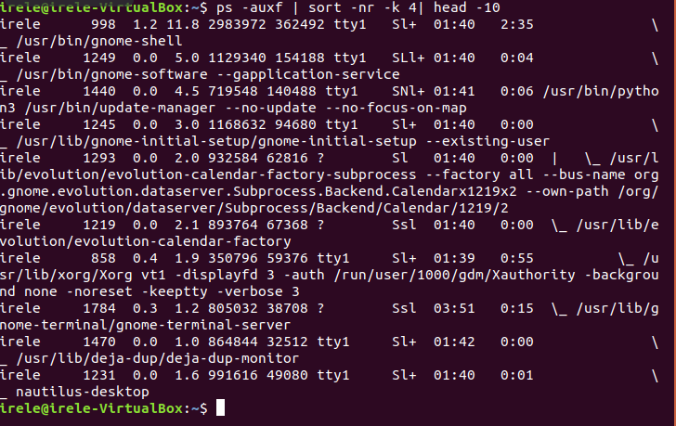

1.2 Issue 10 processes consuming the most CPU resource

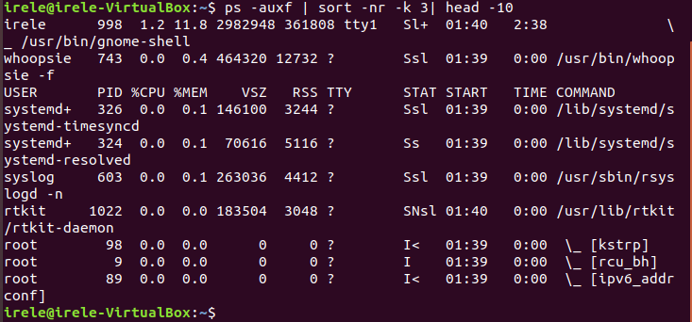

2. **free** – memory usage

The free command shows the total amount of free memory and used by the system physical memory and swap memory, as well as the buffer sizes used by the kernel.

***# free***

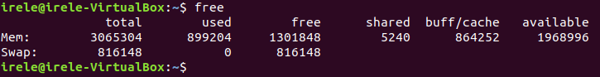

3***. iostat*** – average CPU usage, disk activity

The iostat command displays CPU usage statistics, as well as I/O statistics for devices, partitions, and network file systems (NFS).

***# iostat***

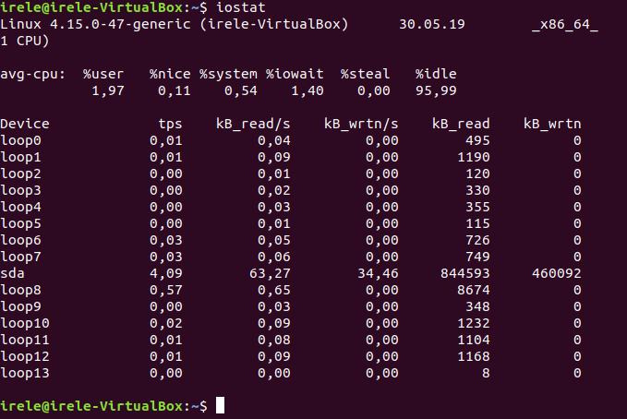

**4. sar – collecting and reporting system activity data**

The **sar** command is used to collect information about system activity and to output it as a report or to save it. To see the value of the network activity scanner, type:

***# sar -n DEV | more***



In order to see the values of network activity counters, starting from the 24th:

***# sar -n DEV -f /var/log/sa/sa24 | more***

With the sar command, you can also output data in real time:

***# sar 4 5***

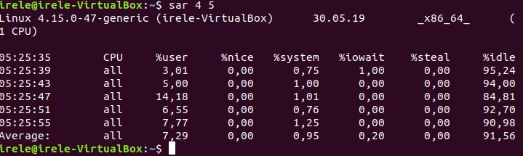

**5. *mpstat* – using the multiprocessor**

The ***mpstat*** command displays the activity data of each available processor, processor 0 will be the first. The ***mpstat -P ALL*** command displays the average usage of resources for each processor:

***# mpstat -P ALL***

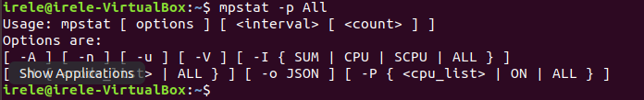

**6. *pmap* – the use of RAM processes**

The ***pmap*** command provides information about the allocation of memory between processes. Using this command will find the cause of the bottlenecks associated with the use of memory.

***# pmap -d PID***

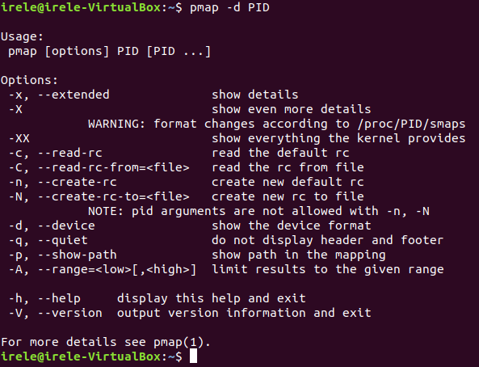

In order to get information about using the process memory with ***pid # 47394***, type:

***# pmap -d 47394***



The last line is very important:

▪ **mapped: 933712K -** total amount of memory allocated for files;

▪ **writeable/private: 4304K -** total private address space;

▪ **shared: 768000K -** the total amount of address space that this process uses in conjunction with other processes.

**Conclusion:**

In this laboratory the following was considered :

***pmap* – the use of RAM processes**

***mpstat* – using the multiprocessor**

**sar – collecting and reporting system activity data**

***iostat*** – average CPU usage, disk activity

**free** – memory usage

Processes and memory used.